**Task 1:**

Check whether /user/acadgild directory exists or not in the HDFS.

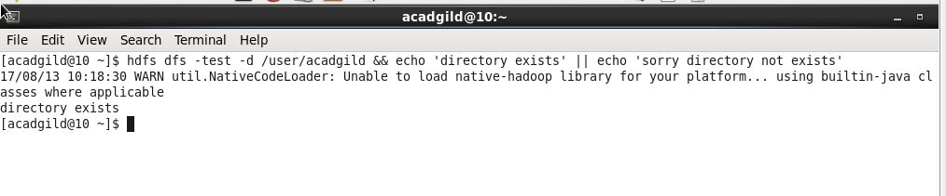

**Syntax:**

$hdfs dfs –test -d /path

**Example :**

$ hdfs dfs –test –d /user/acadgild && echo ‘directory exists’ || echo ‘Sorry directory not exists’

**Task 2:**

Create a file in HDFS under directory /user/acadgild/hadoop, with name word-count.txt.

Whatever we type on screen should get appended to the file.

Try to type (on screen) few lines from any online article or textbook.

Step 1: Create Hadoop directory

E:\big data\Assignment\Assignment 2.1\Session 2 HDFS A2.JPG

**Syntax :**

$hadoop fs –mkdir /directory

**Example :**

$hadoop fs –mkdir /user/acadgild/Hadoop

**word-count:**

